# 



03

0

/

20

/

4

2

3



WEDE5020

Claudine Naomie Premice Moughola

*ST10303069*

I. 1

II. Idea of the POE Website 3

III. Assets 4

IV. Website Page and Content 10

A. Homepage 10

B. About Us 10

C. Menus 10

D. Reviews 11

E. Contact Us 11

# Idea of the POE Website

My name for the website is Tchopify_G9 and it is centred around my restauration project about Gabonese food, for those Gabonese who are abroad like me. I intend to establish a business resolving around catering with food from Gabon. We know how difficult leaving one’s homeland is. Social and cultural differences are sometimes complicated to overcome.

This website mainly targets Gabonese customers, but even though, everyone is welcome. Gabonese or not.

Every owner of restaurant would like to see one’s project being seen by the whole world. Tchopify_G9 offers to visitors a small glimpse of Gabonese culinary diversity and helps them seeing a magnificent facet of Gabon. I’m sure that not everyone knows this country, but even though, one can enjoy this taste pleasure...it’s worth it. Wink to my fellow citizens, the website offers to them the effect of a stepping back by making them feel at home through the different menus. Being someone passionate of cooking and Gabonese food, it is a pleasure to share my passions with people so that I’m able to improve myself through their reviews. And what could be better for a restaurant’s owners than achieve perfection according to their client’s requests?

A restaurant does not really have specific objectives if it’s not satisfying the client’s taste buds. What about its website though? It has to make sure that it meets their expectations according to the announced project. A website is obviously one of the opportunities to attract a maximum of foreigners who may be interested in new taste discoveries. Of all the aspects of Gabon, I intend to contribute at least to the discovery of its culinary aspect:

promote Gabonese food, this is the main goal. Therefore, I hope to extend this project in other African countries, where Gabonese are most in majority, such as Senegal, in order to make them feel comfortable in those foreign lands.

# Assets

These are all the sourced materials I intend to use on the website. 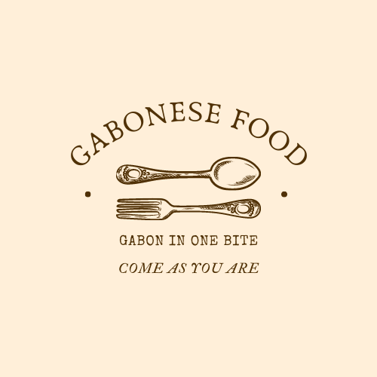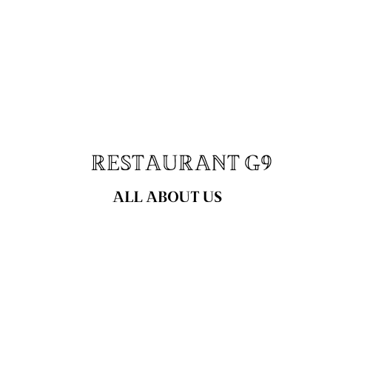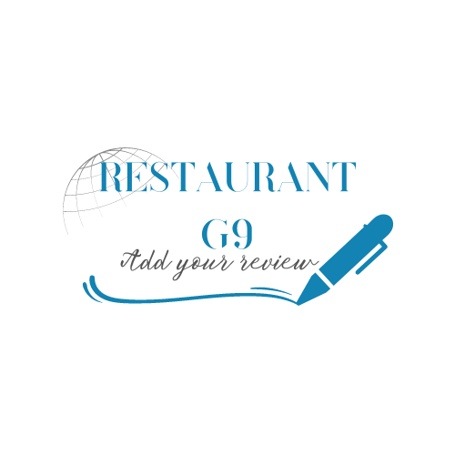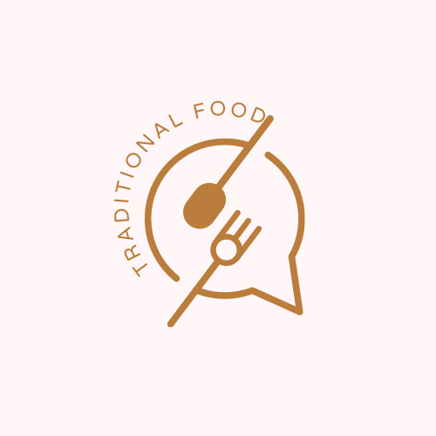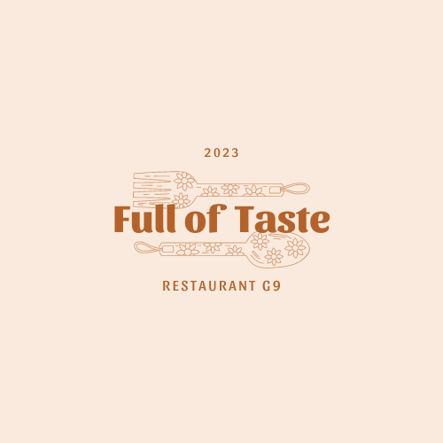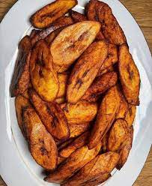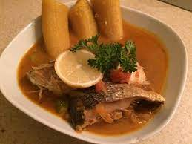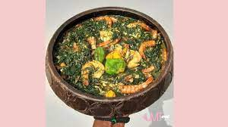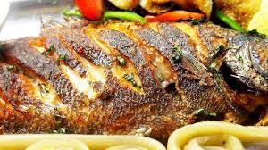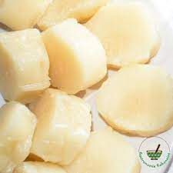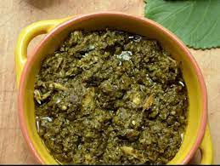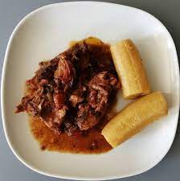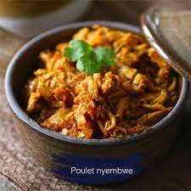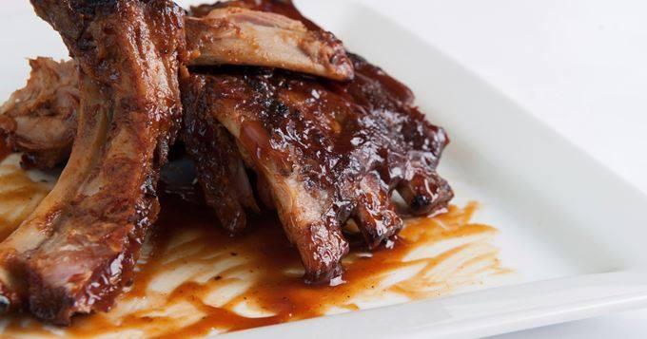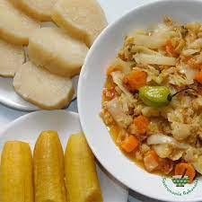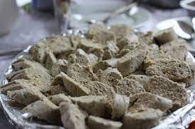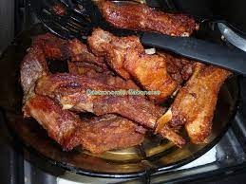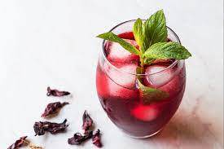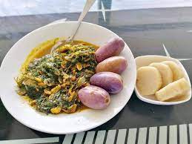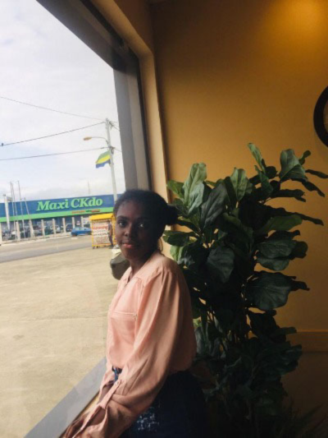

# References

196 flavors, 2015. *Nyembwe Chicken.* [Online]   
Available at: https://www.196flavors.com/nyembwe-chicken/

Afrik Cuisine, 2023. *Recettes.* [Online]   
Available at: https://www.afrik-cuisine.com/recettes/bouillon-de-poisson-2445

Aistou, 2021. [Online]   
Available at: https://aistoucuisine.com/recettes/jus-de-bissap/01/02/2021/

Anon., n.d. *Pinterest.* [Online]   
Available at: https://fi.pinterest.com/pin/634937247460053898/

Appetites, A., 2016. *Mains.* [Online]   
Available at: https://arousingappetites.com/poisson-sale-gabonese-salted-cod-stew/

Arounsing Appetites, 2016. *Mains.* [Online]   
Available at: https://arousingappetites.com/poisson-sale-gabonese-salted-cod-stew/

BADGYAL Magazine, 2023. *Twitter.* [Online]   
Available at: https://twitter.com/BadgyalMagazine/status/1244946519066886144  
[Accessed 31 March 2020].

BADGYAL Magazine, n.d. *Twitter.* [Online].

Canva, n.d. [Online]   
Available at: https://www.canva.com/

Chef Malax, 2021. *Recettes.* [Online]   
Available at: https://www.la-gabonaise-de-cuisine.com/recettes-de-cuisine/poulet-fume-odika/

Cuisine, A., 2018. *Africa Cuisine.* [Online]   
Available at: https://africa-cuisine.com/fr/recipe/bissap-jus-dhibiscus/

Gastronomie Gabonaise, n.d. *Gastronomie Gabonaise.* [Online]   
Available at: https://www.facebook.com/GastronomieGabonaise/posts/3084299595032320/  
[Accessed 15 September 2020].

Hyacine KA, 2017. *Twitter.* [Online]   
Available at: https://twitter.com/HyacineKa/status/834392796534566912

RECETTES AFRICAINES, n.d. [Online]   
Available at: https://recettesdafrique.com/recette/lait-caille-yaourt-maison/  
[Accessed 03 April 2023].

Sports, L. d. l. r. d. T., 2017. CAN 2017. *Africa Top Sports,* pp. 15-16.

Tawuik, R. L., 2016. *Products.* [Online]   
Available at: https://letawuik.insight.cg/en/shop/product/poissons-poisson-braise-1026

Tawuik, R. L., 2017. *Poisson Braise.* s.l.:s.n.

Tawuik, R. L., n.d. *Poisson Braise.* s.l.:s.n.

* You are always welcome to Restaurant G9. You can book at any time and we will do our best to meet your needs. Restaurant G9 is a catering company that is centred on Gabonese food. We offer you a trip to west-central Africa and a diversity of taste pleasure. Our principle: no matter who you are, just come as you are.
* We are a team that is trying to help people who are experimenting culture shock, precisely people from Gabon.

Why Gabonese food? We know how difficult leaving one’s homeland is. Restaurant G9 is an idea of Miss Naomie Moughola, Gabonese student in Higher Certificate at Monash University, also victim of culture shock in South Africa since 2022. We are doing our best so that Gabonese people like her feel comfortable, even in unfamiliar territory. But don’t worry, it’s your home too. Africa wins!

# Website Page and Content

1. Homepage.
2. About Us.
3. Menus.
4. Reviews.
5. Contact Us.

## Homepage

1. Logos.
2. Slogan.
3. Links to other pages.
4. Summary of the main activity of the organization.
5. Address.
6. Schedule.
7. Picture of a dish.
8. Copyright/Year.

## About Us

1. Restaurant’s name + slogan.
2. Logo.
3. Cuisine type.
4. Who are we?
5. Picture of me.
6. Links to other pages.

## Menus

1. Logo.
2. Pictures of some dishes + some descriptions.
3. Some specialties with prices.
4. Links to other pages.

## Reviews

1. Logo.

## Contact Us

1. Logo.
2. Links to other pages.
3. Email.
4. Telephone number.